
CHENNAI INSTITUTE OF TECHNOLOGY
CHENNAI – 600069
Consent Letter for SIH 2026
Terms & Conditions for Participation
By participating, I acknowledge and agree to the following:
1. I am aware that if I am shortlisted for the finals, I may need to work after
academic hours to complete the projects at CoE.
2. I am willing to travel to the nodal centre allotted by AICTE across India.
3. I have informed my parents/guardians regarding the travel.
4. I confirm that I have not joined as a member in any other team.
5. If IA or Semester exams are scheduled during the event, I am willing to take the exams at a later date, as per Institute guidelines.
6. I understand that if I fail to cooperate with my team, I may be removed from the team or the team may be rejected.
Team Name:
S.No | Name | Reg.No | Dept | Year | Gender | Sign
1 | Siddarth V | 2104251040939 | CSE | 2nd | Male | 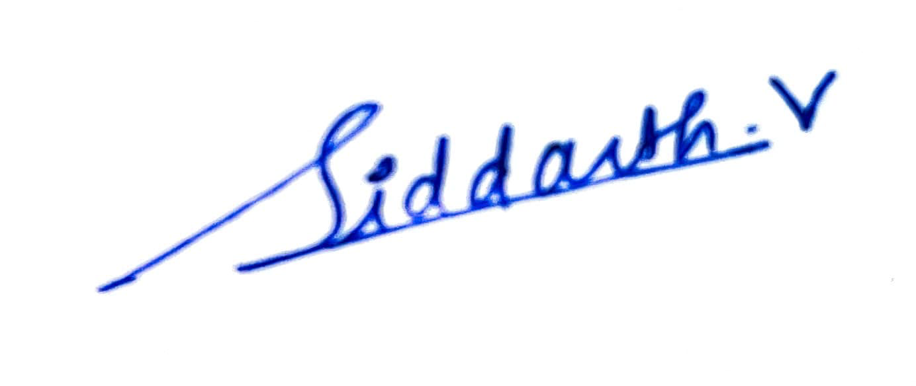
2 | DHAKSHIKA K S | 2104251040185 | CSE - L | 2nd | Female | 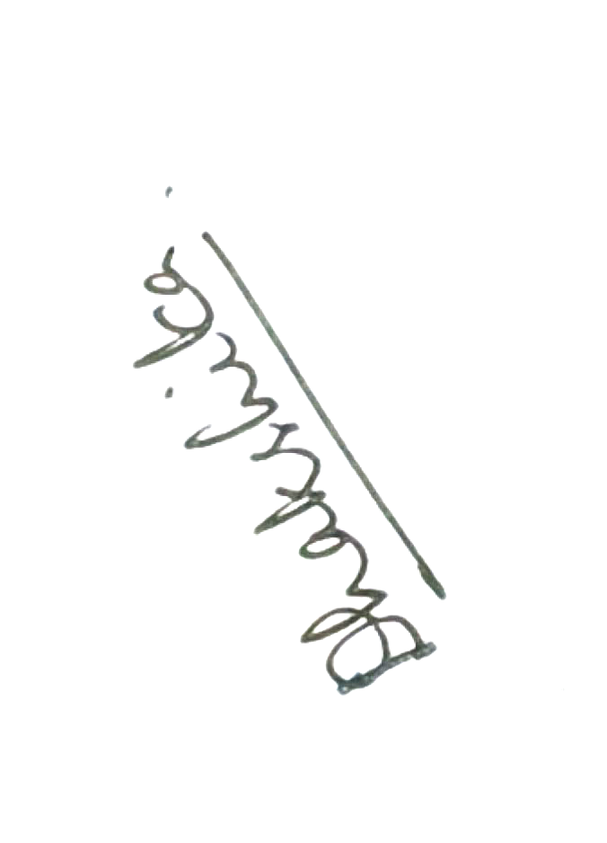
3 | TRIJAL P G | 24CZ0065 | Cyber Security | 3rd | Male | 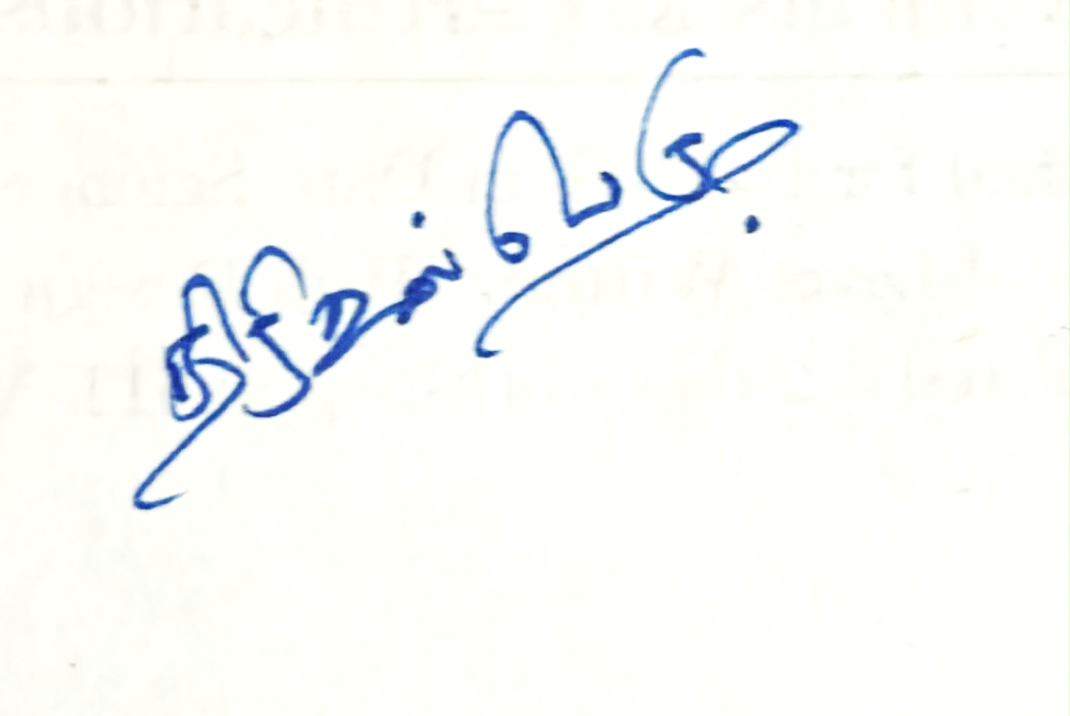
4 | Sanjeev V | 2104251040876 | CSE | 2nd | Male | 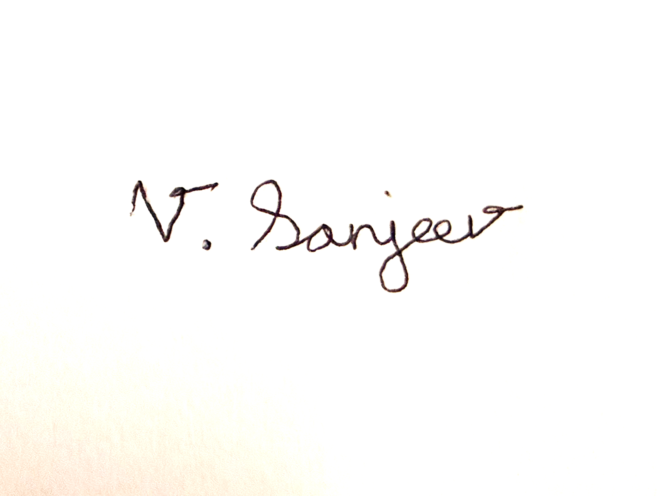
5 | BARATH KUMAR M A | 24CS0125 | CSE | 3rd | Male | 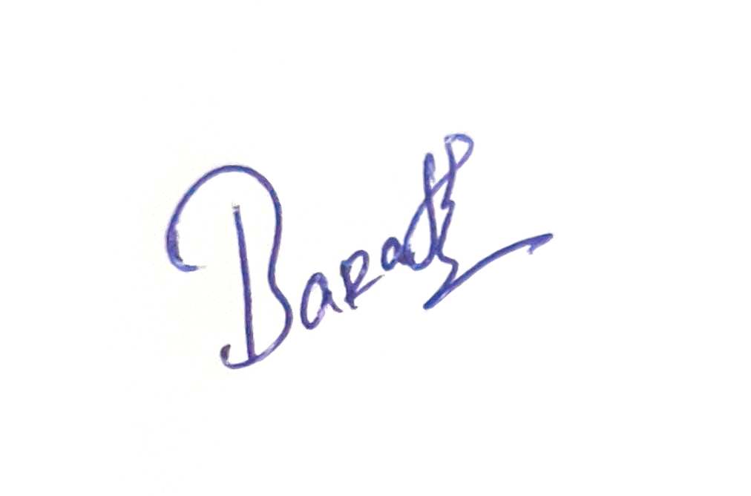
6 | L Harshitha | 210425114057 | Mech | 2nd | Female | 